

Department of Mechatronics Engineering
MECE404 - Intelligent Mechatronics
End of Semester Project

Student’s Name | ID
Abdul Karim | 22244410053
Salman AL-KHULAQI | 22244410048

Comparison of Fuzzy and PID Control in an Anti-lock Braking System on Dry, Wet and Icy Asphalts

1. Objective
The objective of this project is to compare the performance of a fuzzy controller to that of a PID controller in the regulation of slip in an Anti-lock Braking System under different asphalt conditions, namely, dry, wet and icy. The aim is to evaluate which controller performs better in preventing wheel lock-up while maintaining optimal slip ratio throughout the stopping duration.

2. Introduction
Anti-lock braking systems (ABS) are vital safety components in modern day vehicles that prevent wheel lock up when braking aggressively. By controlling the brake pressure, ABS prevents the wheels from locking up by releasing the brakes whenever a loss of traction is detected. Since this ensures the wheels remain in traction with the road, the stopping distance is thereby reduced by always operating under optimal slip ratio.
PID controllers are commonly used due to their simplicity in implementation. However, they struggle to handle tasks that operate under non-linear conditions or environments with high uncertainties like changes in road conditions.
Fuzzy logic controllers, on the other hand, use a rule-based approach like human reasoning which can handle complex and variable systems much better, as is the case in our project with varying friction coefficient values (μ).

3. Methodology
The following parameters were used to simulate the model in Simulink:
Parameters | Description | Value
g | Acceleration due to gravity (m/s²) | 9.81
m | Mass (kg) | 400
Rr | Wheel radius (m) | 0.3
v0 | Initial vehicle velocity (m/s) | 40
Kf | Torque gain over pressure | 1
J | Angular moment of inertia of the wheel (kg.m²) | 5

3.1 Simulation Environment
The ABS system was modeled and simulated in MATLAB Simulink using a quarter-car approach. Both PID and Fuzzy logic controllers were implemented within the same structure to allow direct comparison. The desired slip ratios for dry, wet and icy asphalts were set to 0.15, 0.1 and 0.2 respectively. Simulation times were set to 20s, 26s and 190s respectively for dry, wet and icy asphalts.
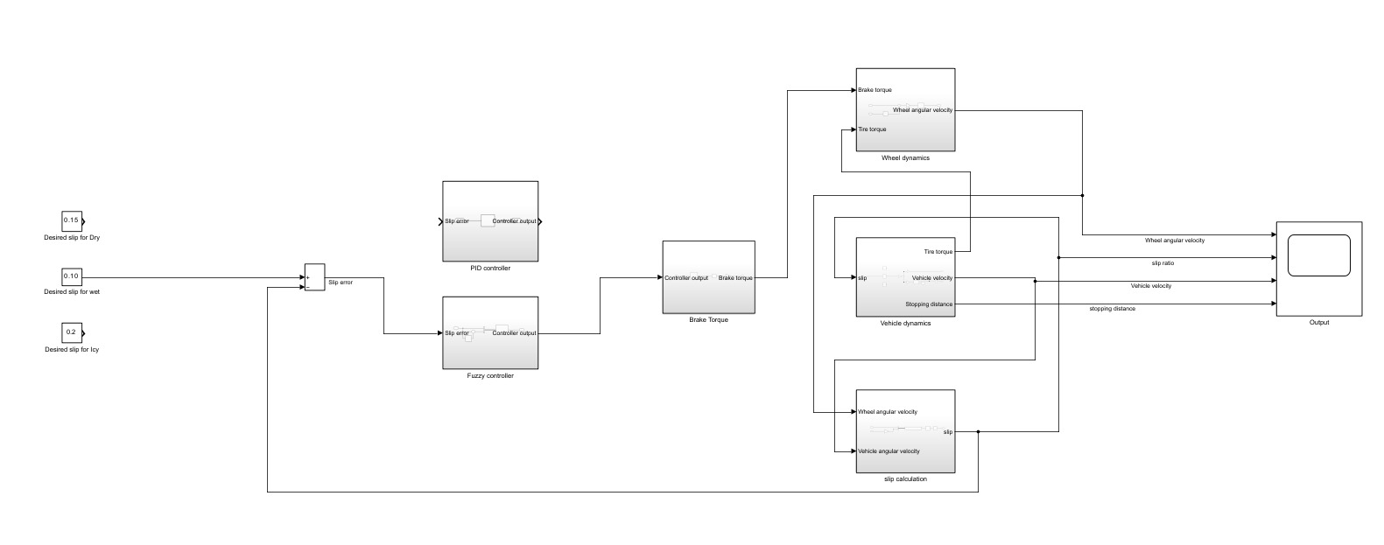

3.2 Controllers
A fuzzy and a PID controller were utilized.

3.2.1 PID Controller
Takes 1 input slip error and outputs brake pressure.
Through extensive tuning, the values of Kp, Ki and Kd were chosen to be 20, 18 and 2 respectively. These gave us the best results.
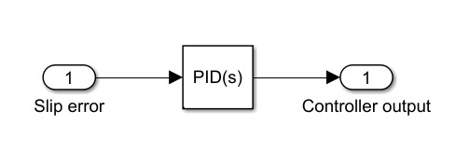

3.2.2 Fuzzy Controller
Takes 2 inputs, slip error and rate of change of slip error, and outputs brake pressure.
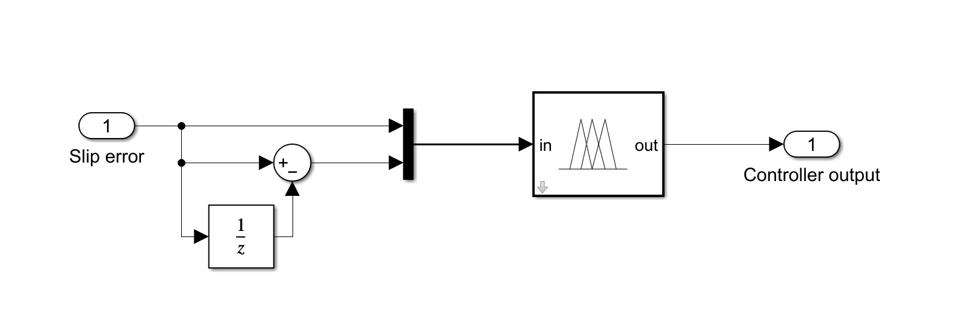
Input1 used triangular membership functions whereas Input2 used both triangular and trapezoidal. The language values of input parameters are:
1. NL : negative large.
2. NS : negative small.
3. ZE : zero.
4. PS : positive small.
5. PL : positive large.
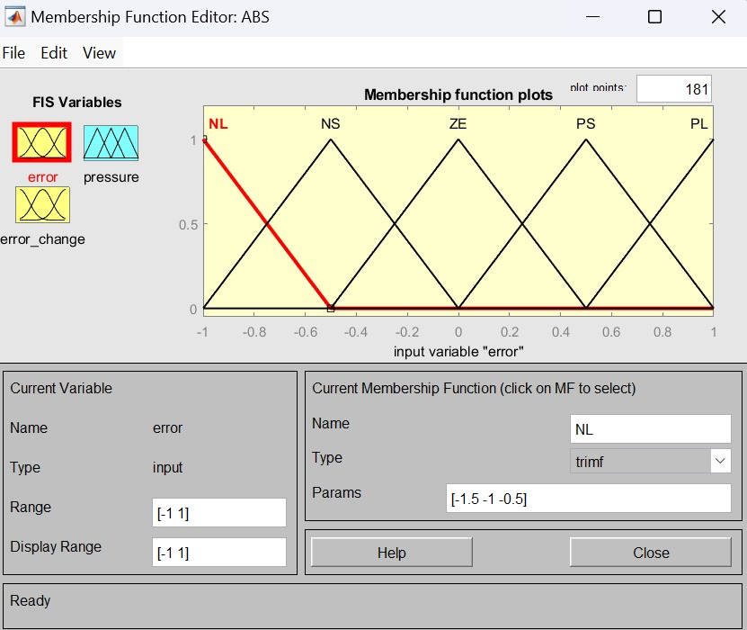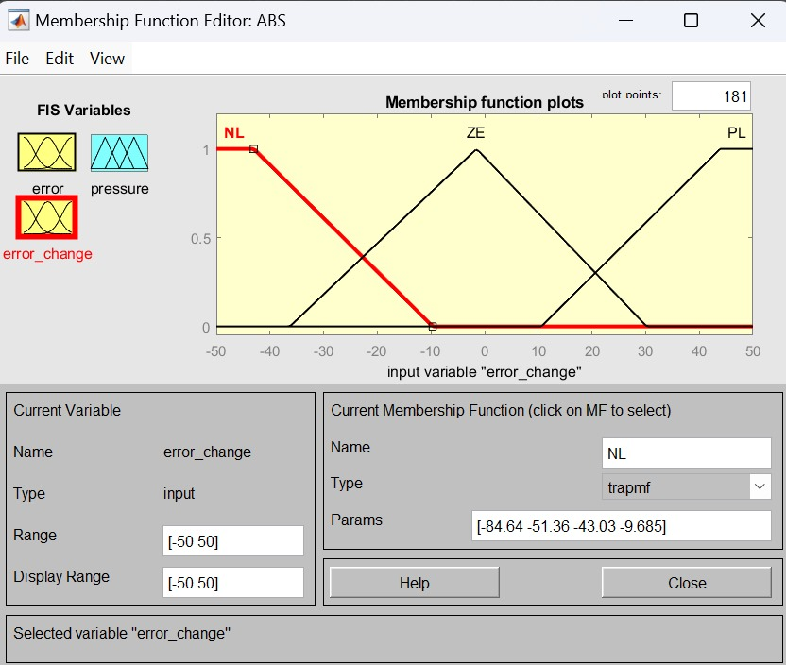
The output used triangular membership functions. The language values of the output parameter are:
1. DPL: quickly reduce the pressure.
2. DPS: slowly reduce the pressure.
3. HOLD: hold the pressure.
4. IPS: slowly increase the pressure.
5. IPL: quickly increase the pressure.
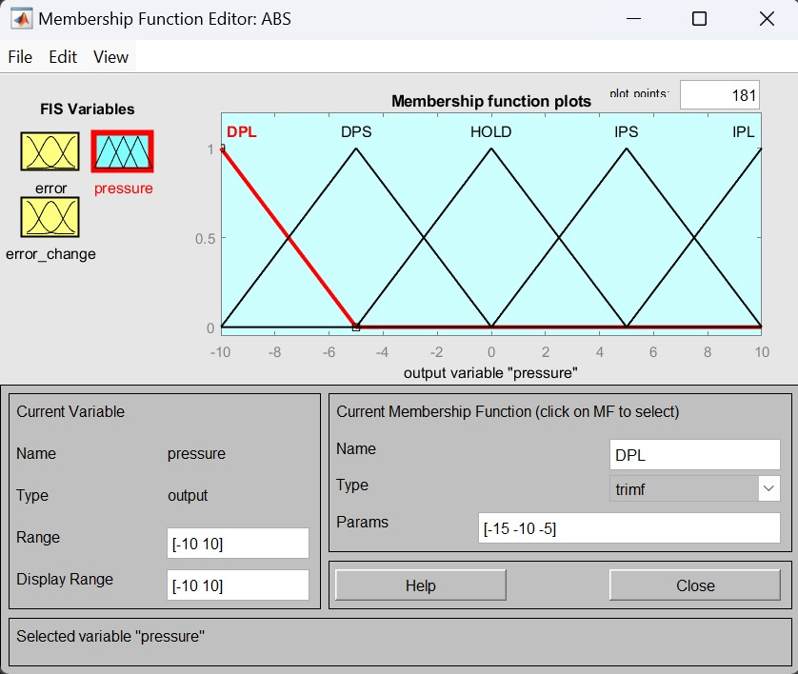
For this project, IF-THEN rules were used to relate the input variables to the output. The firing strength was calculated using the mamdani inference system. The rule-base used is provided below:
Error/ Error change | NL | ZE | PL
NL | DPL | DPS | HOLD
NS | DPL | DPS | HOLD
ZE | DPS | HOLD | IPS
PS | HOLD | IPS | IPL
PL | HOLD | IPS | IPL

3.3 Pressure-to-Torque Conversion
The output of both PID and fuzzy controllers is treated as a brake pressure which is transformed into brake torque using a first-order transfer function followed by an integrator to model the actuator dynamics.
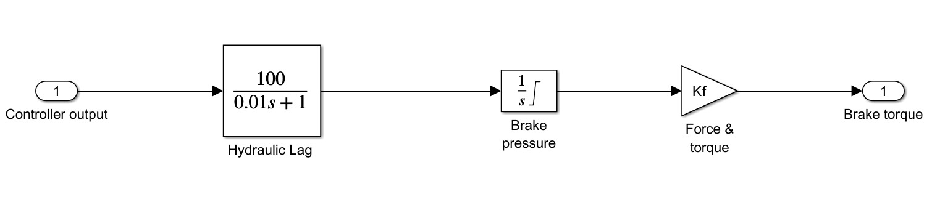
Transfer function:
$$G(s)=\frac{100}{0.01s+1}$$
Torque output:
$$T_{b}\left(t\right)=\int_{0}^{t}{G\left(s\right)∙{\dot{T}}_{b}\left(s\right)ds}$$
Torque saturation:
$0≤T_{b}≤1500 Nm$

3.4 Vehicle Dynamics
The x-axis motion of the vehicle is governed by Newton's second law, where the friction force generated at the tire-road interface causes deceleration.
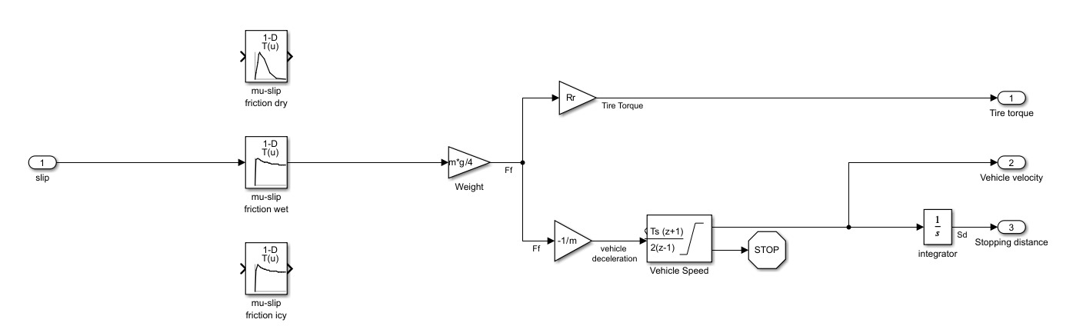
$$F_{i}=F_{f}=μ∙N=μ∙m∙g$$
Resulting in:
$$\frac{dv}{dt}=-μ∙g$$
Look-up tables are used to calculate the μ value for the corresponding slip. Integrating the velocity gives us the stopping distance.
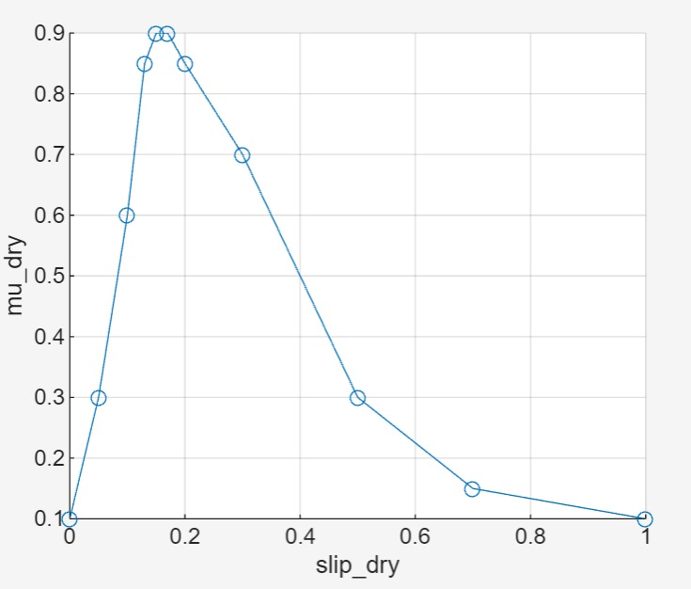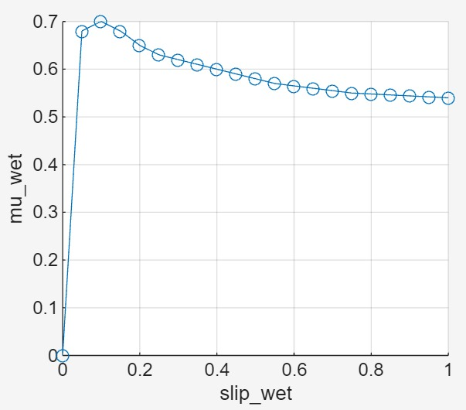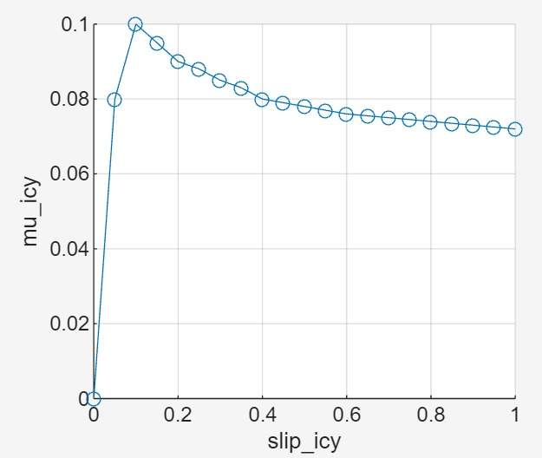

3.5 Wheel Dynamics
The rotational dynamics of the wheel under braking are affected by the applied brake torque T_{b} and the friction force acting on the point of contact.
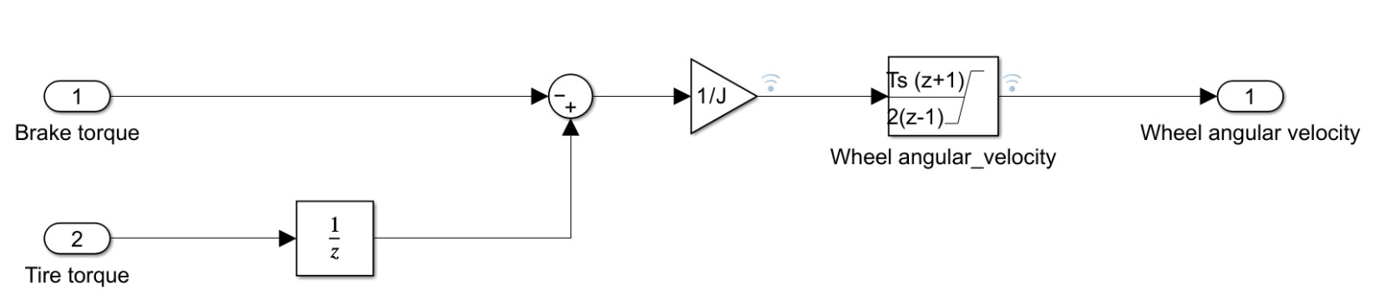
$$\frac{dω​}{dt}=\frac{1}{J}∙(-T_{b}+μ∙m∙g∙r)$$

3.6 Slip Ratio Calculation
Slip is calculated as the relative difference between vehicle and wheel angular speeds. In this model, it is calculated using a safe formulation to avoid division by zero by using a small value ε.
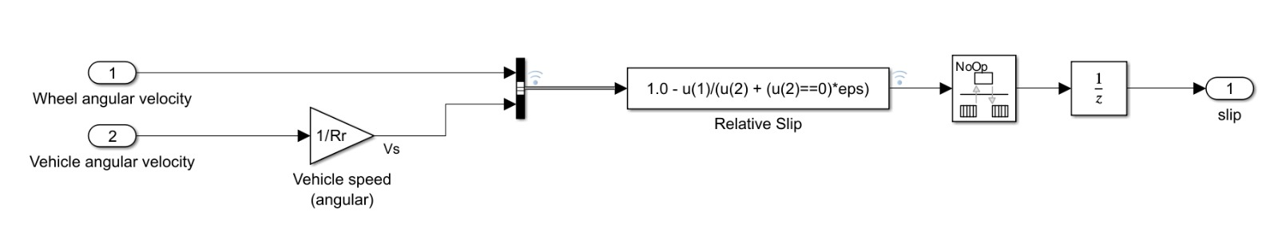
$s=1-\frac{ω_{w}}{ω_{v}+ε}$ , with ε <<0.1
This expression captures the proportional slip between vehicle motion and wheel rotation, which is critical for determining tire-road traction and the coefficient of friction (μ).

4. Results

4.1 Dry Asphalt
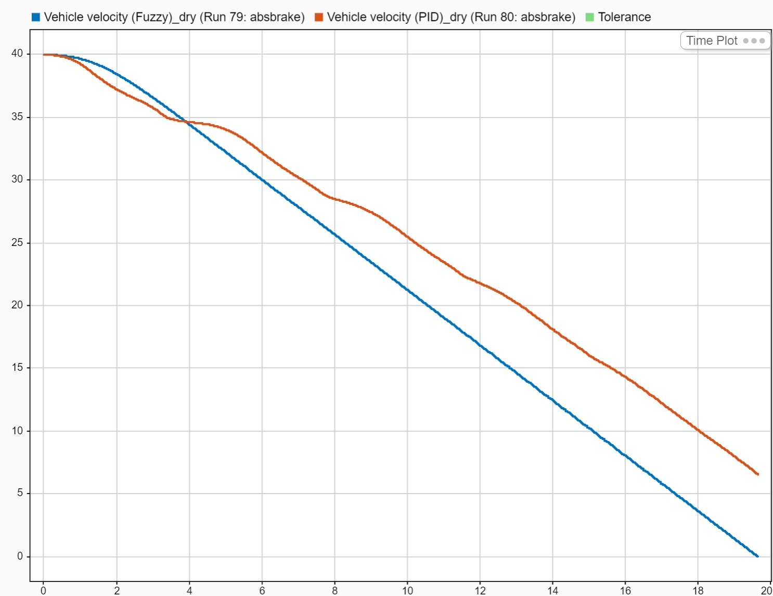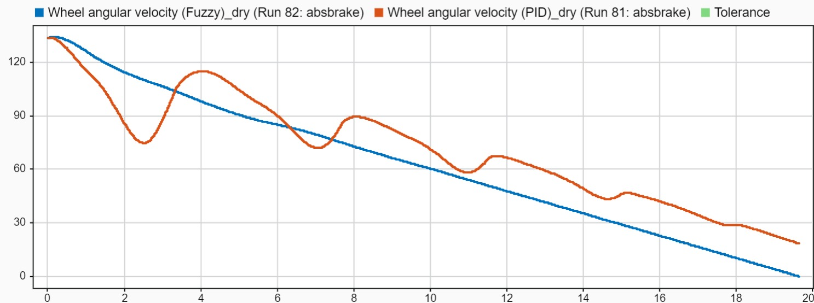
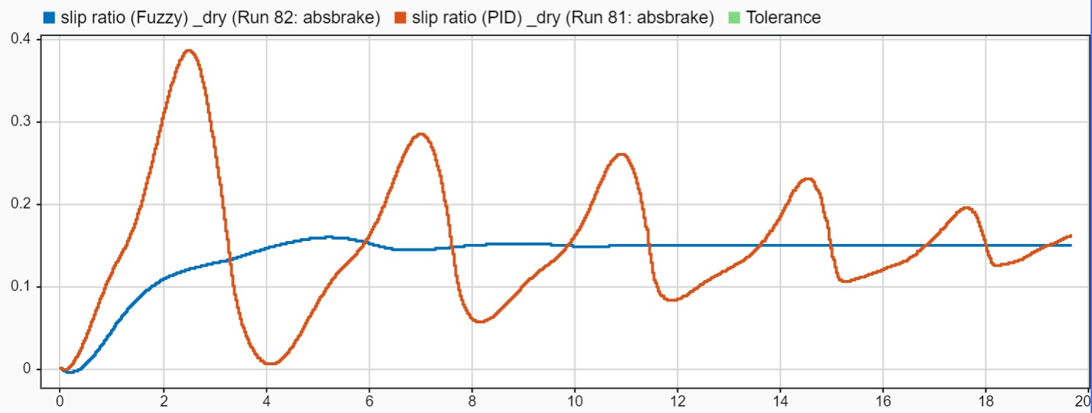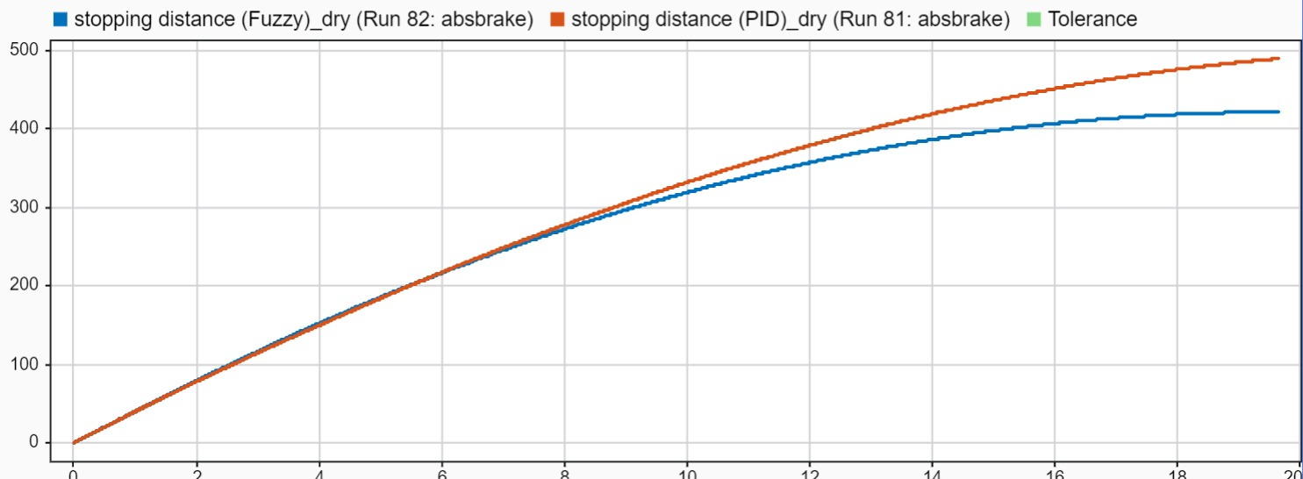

4.2 Wet Asphalt
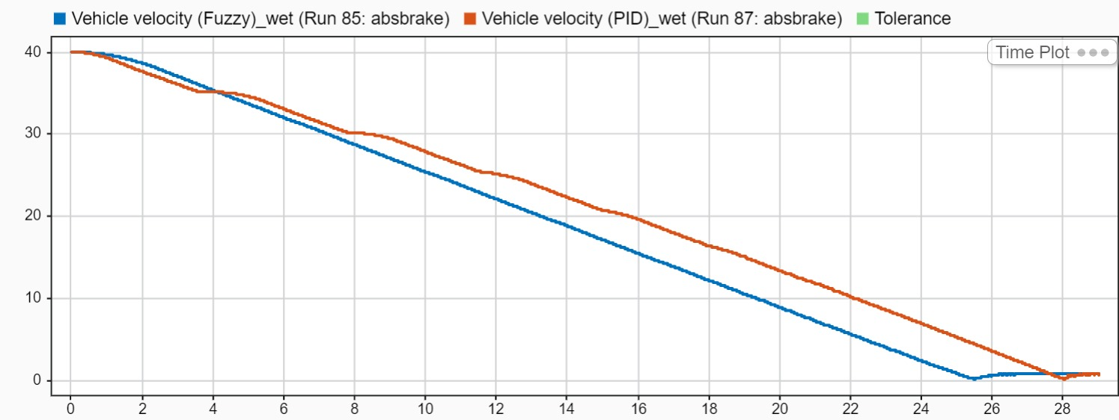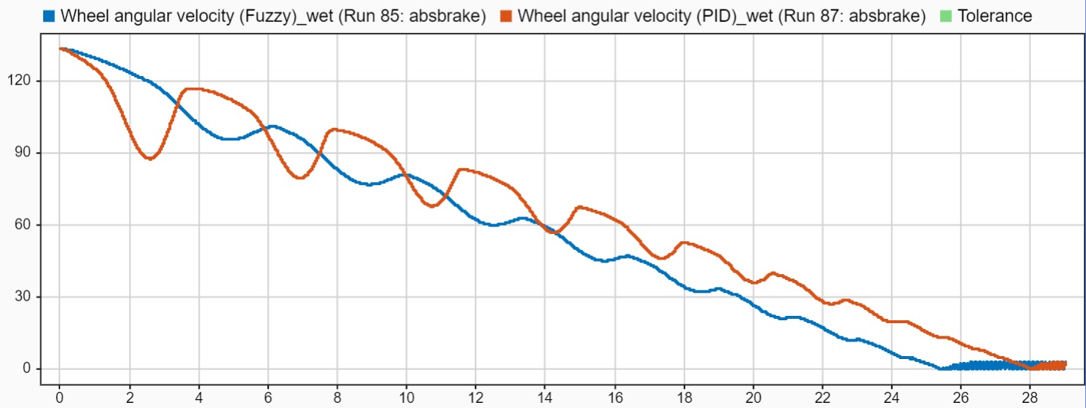
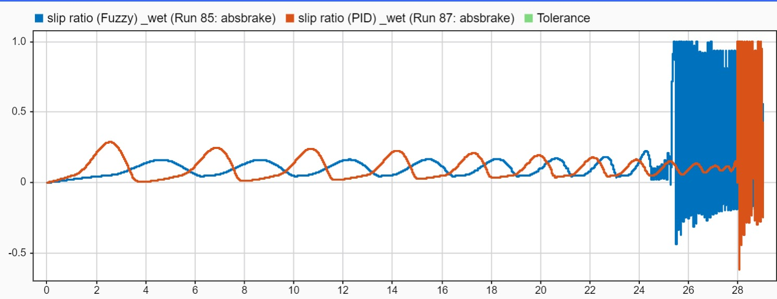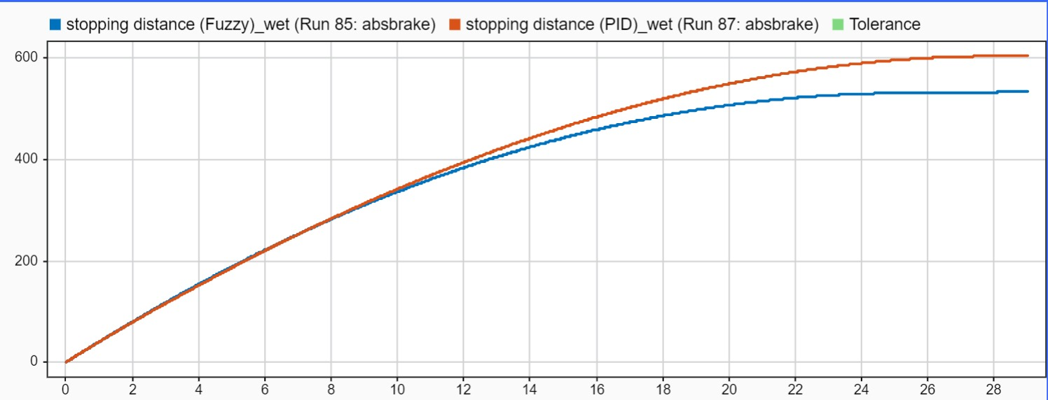

4.3 Icy Asphalt
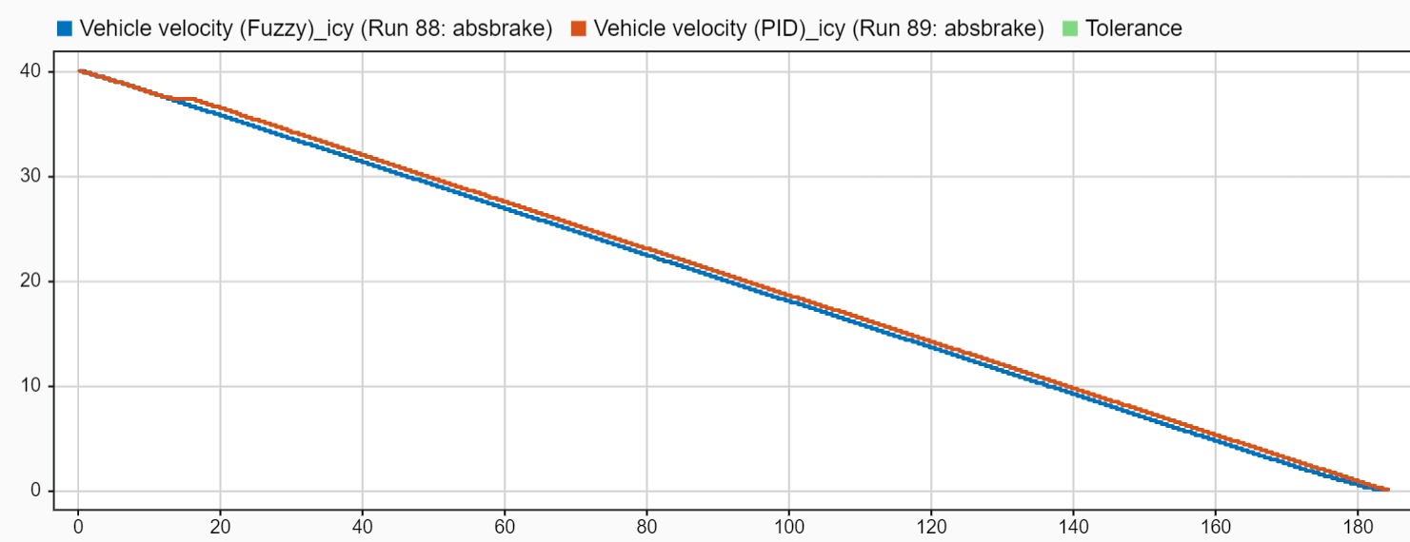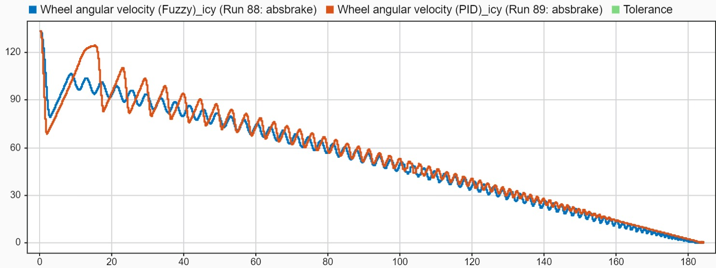
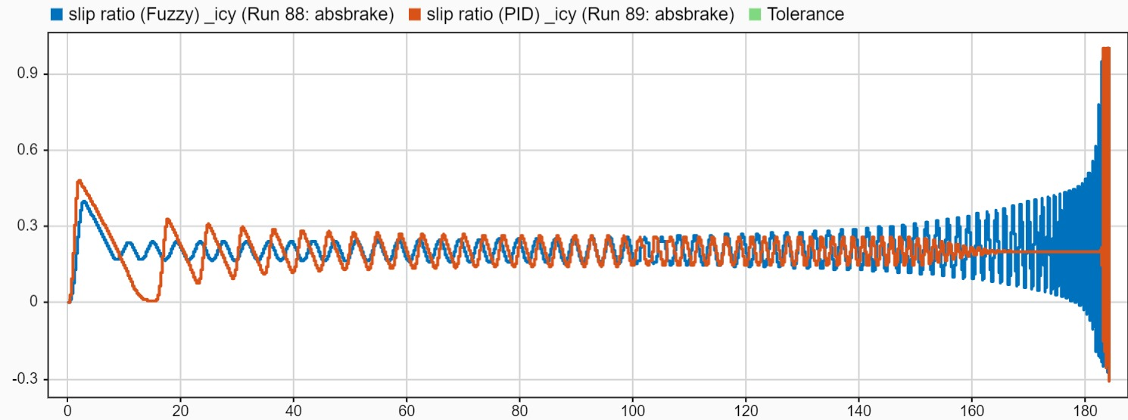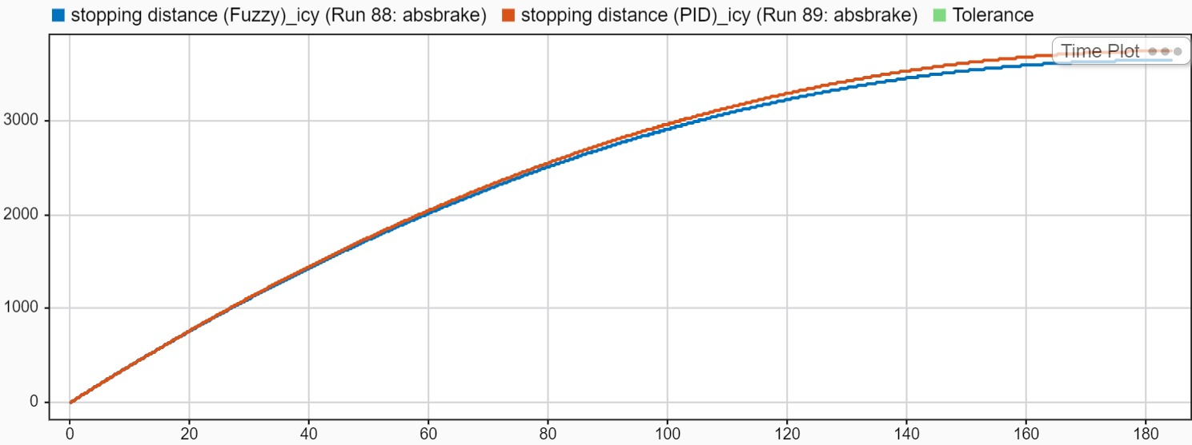

5. Discussion

5.1 Dry Asphalt Performance
Wheel Speed:
- The PID controller shows more aggressive oscillations in wheel speed, with higher frequency variations throughout the braking process.
- The fuzzy controller maintains smoother wheel speed transitions with reduced oscillatory behavior.
- Both controllers effectively prevent complete wheel lockup, but the fuzzy controller shows better stability and absolutely no oscillations.
Vehicle Speed:
- Both controllers achieve similar deceleration performance.
- The PID controller shows slightly more sudden changes compared to the fuzzy controller.
- The fuzzy controller provides more consistent deceleration with smoother speed reduction which results in the vehicle stopping faster.
Slip Ratio:
- The PID controller struggles to maintain the desired slip ratio of 0.15, showing significant overshoot and undershoot with constant oscillations.
- The fuzzy controller demonstrates superior slip ratio tracking, maintaining closer proximity to the target value with minimal deviation.
- The fuzzy controller's rule-based approach proves more effective in handling the nonlinear tire-road interaction dynamics.
Stopping Distance:
- Both controllers achieve comparable final stopping distances, indicating similar overall braking effectiveness.
- The fuzzy controller stops the vehicle at a shorter distance compared to the PID likely due to its better control.
This asphalt shows the highest difference between the 2 controllers since the coefficient of friction (μ) varies a lot with changes to slip ratio.

5.2 Wet Asphalt Performance
Wheel Speed:
- The PID controller shows large oscillations in wheel speed, particularly during the initial braking phase.
- The fuzzy controller maintains more stable wheel speed behavior with fewer high frequency variations.
- Both controllers adapt to the reduced friction conditions but the fuzzy controller shows better stability and lower oscillations compared to the PID.
Vehicle Speed:
- Extended stopping time is observed for both controllers due to reduced friction coefficient on wet surfaces.
- Overall deceleration performance is similar between both controllers despite different control strategies.
Slip Ratio:
- The PID controller shows significant difficulty maintaining the target slip ratio of 0.1, with notable oscillations and poor tracking performance.
- The fuzzy controller demonstrates superior performance, staying closer to the desired value with minimal overshoot.
- The reduced friction conditions amplify the PID controller's limitations in handling nonlinear dynamics.
Stopping Distance:
- Both controllers require increased stopping distances due to wet conditions and achieve similar final performance.
- The fuzzy controller once again stops the vehicle at a shorter distance compared to the PID.
We can see that as the values of the coefficient of friction (μ) lower their degree of variation, the performance of the PID becomes better.

5.3 Icy Asphalt Performance
Wheel Speed:
- The PID controller exhibits extreme oscillatory behavior with large amplitude variations in wheel speed.
- The fuzzy controller also exhibits oscillatory behavior but it’s less aggressive compared to the PID’s.
Vehicle Speed:
- Dramatically extended stopping times are required for both controllers due to the extremely low friction coefficient.
- The performances of both the controllers are very similar in this regard.
Slip Ratio:
- The PID controller fails to maintain the desired slip ratio of 0.2, showing extreme oscillations and poor tracking
- Although the fuzzy controller also fails to maintain a constant track of the desired slip, its oscillations have lower amplitude and are closer to the desired value compared to the PID’s.
Stopping Distance:
- Extended stopping distances are observed for both controllers, but the fuzzy controller achieves slightly better overall performance.
- Since the values of the coefficient of friction vary less with changes to slip ratio in icy asphalts, the higher oscillations of the PID don’t really affect the performance.
This category is the closest between the PID and fuzzy due to the coefficient of friction (μ) having little to no variation with changes to slip.

6. Conclusion
This study shows that overall, fuzzy controllers work better than PID controllers in ABS systems, especially on dry roads. The difference between the two controllers gets smaller as road conditions get worse.
The main finding is that controller performance depends on how much the friction coefficient (μ) changes when slip ratio changes. On dry roads, where μ changes a lot with slip, the fuzzy controller performs much better with accurate slip control, less shaking, and shorter stopping distances. As roads get wet and then icy, where μ doesn't change as much, both controllers perform more similarly.
The fuzzy controller always shows better slip control and less oscillatory behaviour in all conditions, though both controllers have trouble on very icy roads. The PID controller works worst when friction changes a lot, because it can't handle these non-linear complex changes well.
While the fuzzy controller always stops the car in a shorter distance, this improvement becomes very small on icy roads where both controllers stop at similar distances. These results show that fuzzy control works best when friction changes a lot with different conditions, making it most useful for cars that drive on many different types of roads/surfaces with varying degrees of friction.

